Module 5: Configuration Management with Ansible Case Study Statement

Problem Statement

Rashford assoc. are having trouble provisioning their server environment because of the inconsistencies caused by the new update. They have Hired Marcus to solve their problems

related to managing servers. Marcus, after researching, introduced Ansible to the system. Now, he needs to provision the production environment for the upcoming update of their software.

Action Items

•Create separate roles for setting up Apache Tomcat and Apache Maven

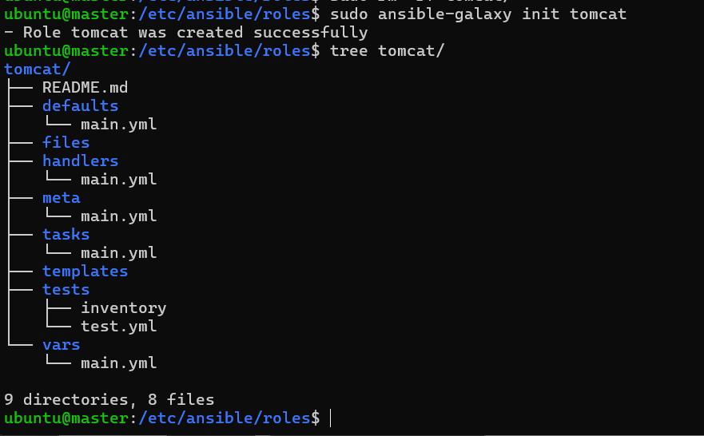

•Add the necessary logic to the roles to set up the tools

•Create a new playbook and call Tomcat as well as Maven roles inside it

•Execute the playbook on all the hosts

